PH126 Logic I  Lecture 3
Lecturer: s.butterfill@warwick.ac.uk
Proofs with ∧
Rules of proof are given near the end of the textbook.
example
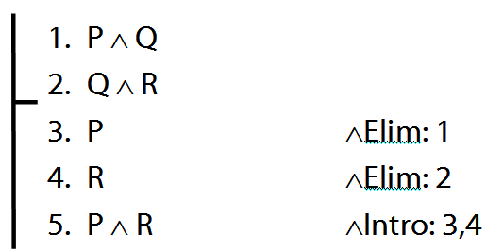

Proofs with identity
example (with missing justification)
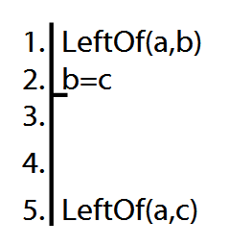

Truth-functional connectives
A connective joins one or more sentences to make a new sentence. E.g. ∧, ¬, because
A sentence joined by a connective is a constituent sentence. E.g. P in “P because Q”
A truth functional connective produces a new sentence whose truth value depends only on the truth values of its constituent sentences.
When P and Q are both true, “P because Q” is sometimes true and sometimes false. Therefore, ‘because’ is not a truth-functional connective.
Complex truth table example
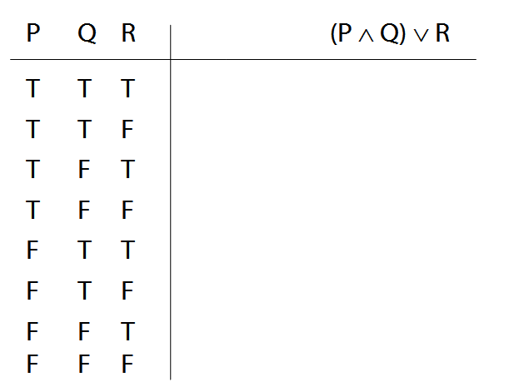

How to order reference columns
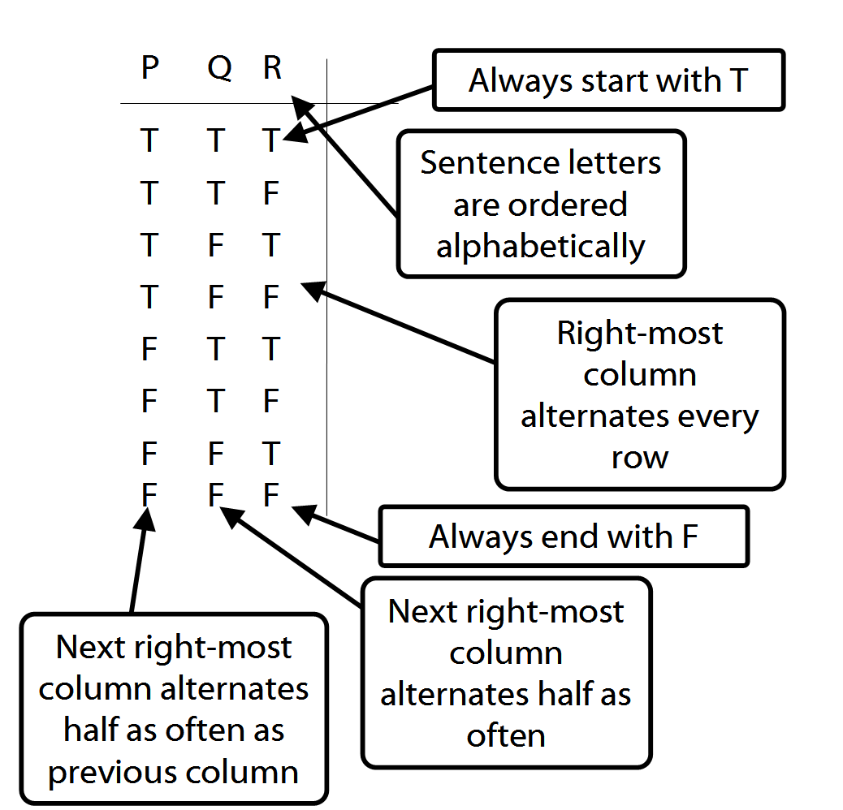
Logical Validity
Argument 3
1. (P ∧ Q) ∨ R
2. P ∨ ¬P
Argument 3b
1.
2. P ∨ ¬P
Argument 4
1. P ∧ ¬P
2. (P ∧ Q) ∨ R
P ∨ ¬P is a logical truth (see p. 568)
P ∧ ¬P is a contradiction (see p. 564)

Exercises 01
For your second seminar. Not for fast groups
A. From the textbook:
2.5–6 (informal proofs with identity)
2.8, 2.10, 2.12, 2.21 (counterexamples)
3.1–2 (negation)
3.5, 3.7 (conjunction)
4.1–2 (truth tables)
B. Explicate each of the following in one or two sentences.
- logical consequence | - FOL  - Fitch format
- logically sound argument

